CAP Scholarships ~ How it All Started:

In 2010, AiPF was named a recipient of the Eva Marder Charitable Remainder Trust. The donation was earmarked specifically for $500 CAP Scholarships and allowed the Foundation to award 68 scholarships. Les Winston, AiPF President, gave us the story behind the Eva Marder Charitable Remainder Trust gift:
Eva Marder was a hard working retail merchant alongside her husband David. For many years, they owned a ladies wear store near Lincoln Road on what is today known as South Beach, Florida. The business was successful and operated until they retired in 1981. Evie's life was thrown into upheaval when David died soon after retirement, and she was left alone to handle everything that had been done by David for all the years they were married.
I met Evie in 2000 through a referral from a client. Evie was 85 at the time and had been managing her own plans and investments. She had recently gone through some medical issues, and she became very anxious about her future.
I began advising Evie and together we reached a plan that would do everything Evie wanted. I spent many delightful hours with this affable, good humored, and generous lady. Evie used to refer to me as the son she never had, and I was happy to be her "most" trusted advisor. Many times, she would thank me for how relieved and calm she felt about her future.
In 2005, I told Evie about the CAP designation I had earned from the American College. Evie said, "what did you need that for, you did all of that for me already". I explained that it took me 20 years to learn by my own experiences, what could now be taught in a three year course. That must have impressed Mrs. Marder because just prior to her passing in 2009 at age 94, Evie made the AIP Foundation the sole beneficiary of the Eva Marder Charitable Remainder Trust for purposes of endowing scholarships for the CAP designation. She said at the time," I hope this will make more (advisors) like you".

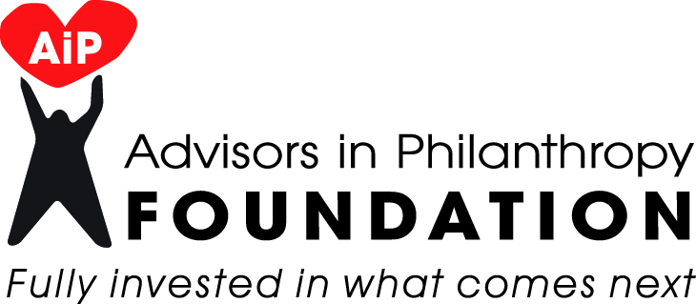

Scholarship Criteria and Application

The mission of the AIPF is to uplift individuals and communities by encouraging and supporting the professional education of advisors in philanthropy.

TO BE ELIGIBLE FOR A SCHOLARSHIP, AN APPLICANT:

*Must be enrolled in the American College’s Chartered Advisor in Philanthropy
OR
Must be enrolled in a non-profit institution of higher learning or coursework that meets the philanthropic mission of the AiPF
AND
Must demonstrate academic and/or professional accomplishment.

*If enrolled in CAP coursework, must sign the pledge below
I pledge to complete to the best of my ability, and with due diligence, the CAP coursework and testing, and by signing this pledge I am obligating myself to become a CAP.

_____________________________________________________________________________________
Your Name Date

The decision to award a scholarship shall be made at the full discretion of the AIP Foundation Board or other body duly appointed by the Foundation Board of Directors.

Applications will be considered in the order in which they are received. You or the contacts you list below may be contacted by an AiPF board member.

Applicants can receive only one AiP Foundation scholarship but may apply more than once if denied.

If an applicant is awarded a scholarship, the scholarship will be sent directly to the institution of higher learning upon successful completion of the course in order to reimburse the payor.

Scholarships awarded must be applied to a course registration within a 45 day time period from the date of application or AiPF may rescind the scholarship.

Forward Scholarship App to: Advisors in Philanthropy Foundation, Inc., 95 West Street, Rocky Hill, CT 06067. Fax to 860-721-7406 or email aipfoundation@snet.net For more info. call 860-721-7400 #3.

AiPF Scholarship Application

Name:

Company:

Address:

City: State: Zip Code:

Office Phone: Cell Phone:

E-mail:

Best time and day to reach you:

Please check the CAP courses you have enrolled in to date:

839______ 849 ______ 859 ______

Please check the CAP courses you have tested for to date:

839______ 849 ______ 859 ______

If you are enrolled in any other program for which you are seeking a scholarship, please indicate the name, address and phone # of the program and when you anticipate graduating:

_____________________________________________________ ____________________
Program Name Year

_____________________________________________________ ____________________
Address Phone

Academic Background
Degree/Designation/Certificate | Institution | Year Received

Professional Awards and/or Achievements: List any personal or professional achievements.
Award/Honor/Achievement | Name of Organization | Year

Employment: Please list current employment going back 10 years.
Company | Dates | Contact name, address, website | Position/Responsibilities/Activities

Volunteer Work/Membership Please list your volunteer work, and organizations you are an active member of.
Organization | Dates | Contact name, address, website | Position/Responsibilities/Activities

How many (please provide an approximate number) of each of the following charitable vehicles have you helped to create at this time in your career?

______ Charitable Remainder Trust ______ Pooled Income Fund ______ Foundation

______ Donor Advised Fund ______ Charitable Lead Trust ______ Non Profit Org.

Why have you chosen to learn more about Philanthropic Planning?

Why are you applying for this scholarship?

Use additional pages, if necessary.

